Database System Engineering and Distributed Backend Development
Course Code: 25CS1302E
Week-2
The Librarian’s Dashboard Scenario The library is now digital! The head librarianneeds a report to see which members are active and which books are in the collection. You also need to handle a "Book Donation" process where a new bookis added and assigned to a category at the exact same time—if one part fails, thewhole process must stop to keep the catalog accurate. Task to be Done 1. TheCatalog Search (JOINs): Create a third table called Loans that connects member_idto book_id. Write a query to show the Member Name and the Book Title they havecurrently borrowed. 2. Collection Stats (Aggregations): Write a query to find thetotal number of books published in each year. o Hint: Use COUNT(book_id) andGROUP BY published_year. 3. The Donation Transaction (ACID): Use aTransaction (BEGIN...COMMIT) to add a new book to the Books table andsimultaneously log the entry in a Donation_History table. 4. Search Speed(Indexing): Create an Index on the isbn column. Explain why searching by ISBN isnow faster for the librarian than searching by Title. Skill Set Gained • RelationalLogic: Connecting independent tables (Books + Members) through a Junction table(Loans). • Analytical SQL: Using GROUP BY to generate business insights. •Atomic Operations: Using Transactions to ensure multiple database changes succeed or fail as a single unit.
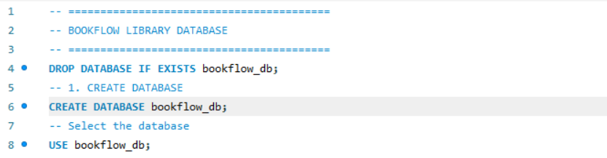

Create Books table
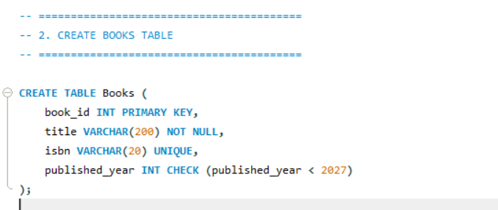
Create Members Table
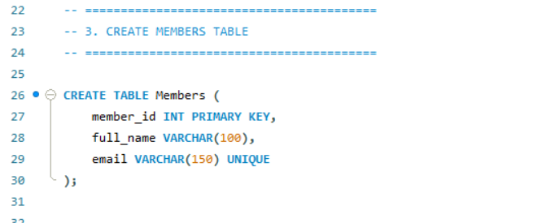

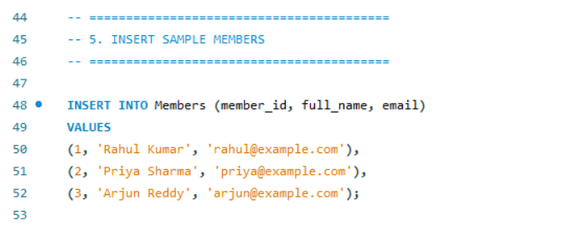
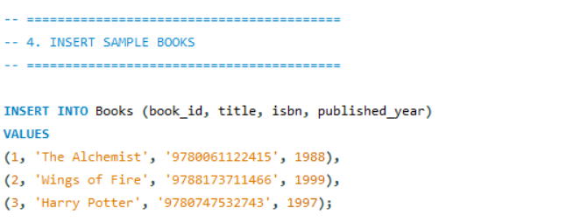
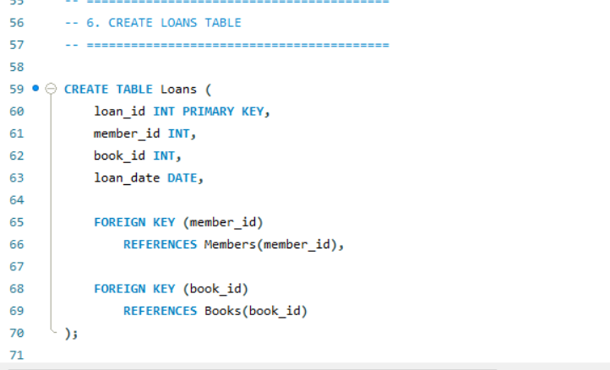
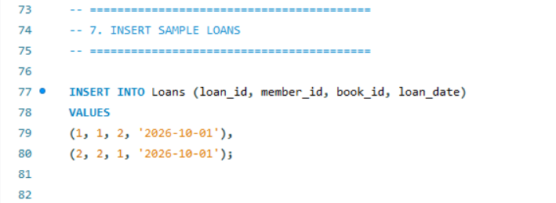
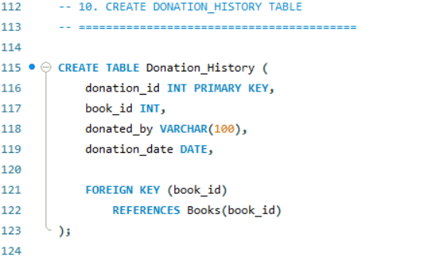
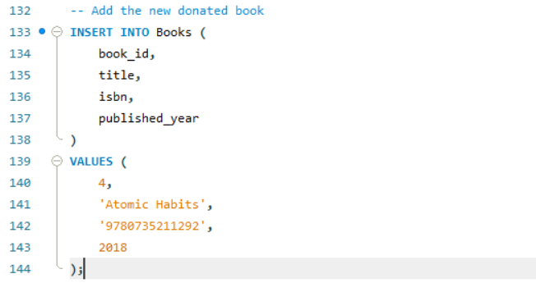
Outputs:
